* **Created an instance “EmineOncuInstance” and it is running.**

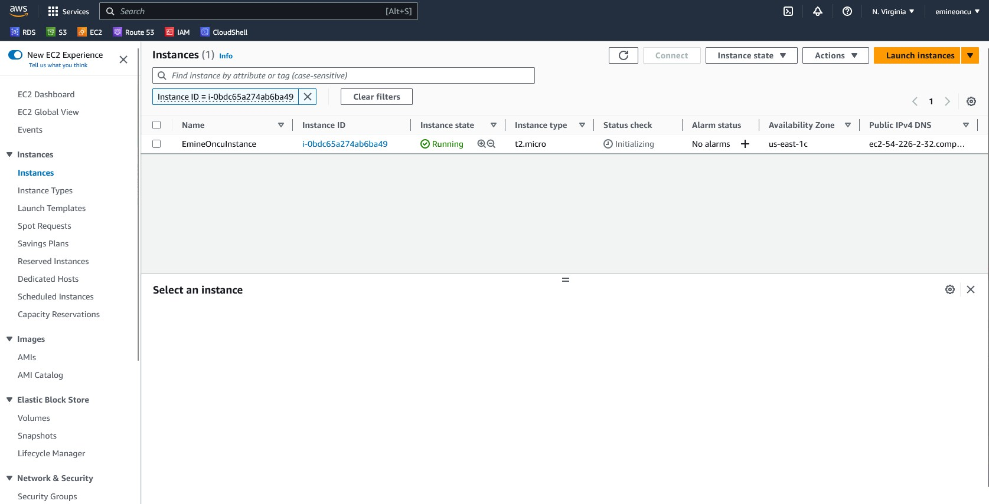

* **Instance summary**

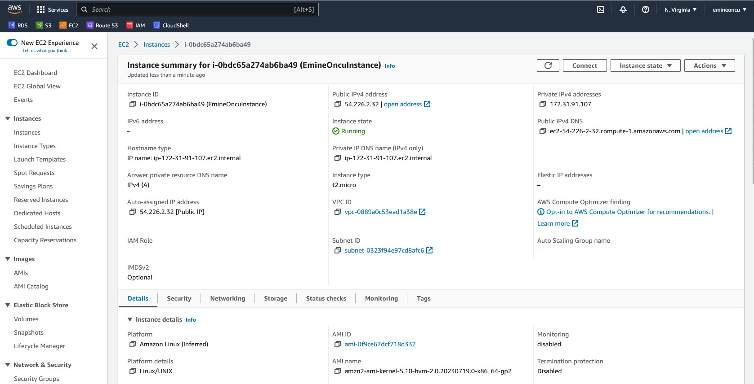

* **Details of Instance and we can be able to see AMI name and ID.**

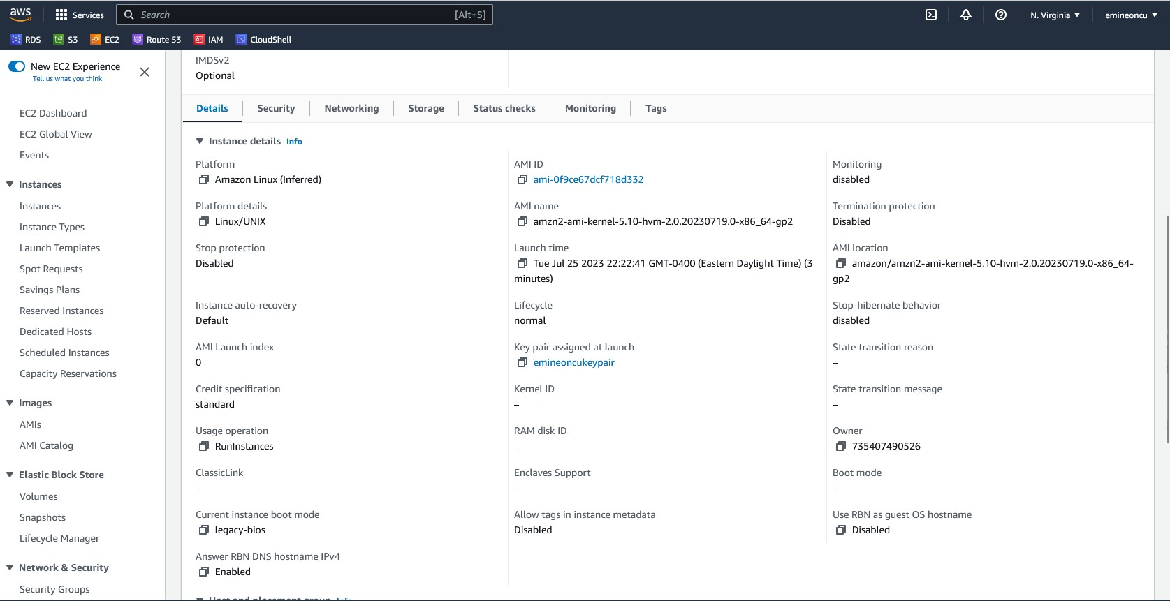

* **We can see the public DNS name in the picture below.**

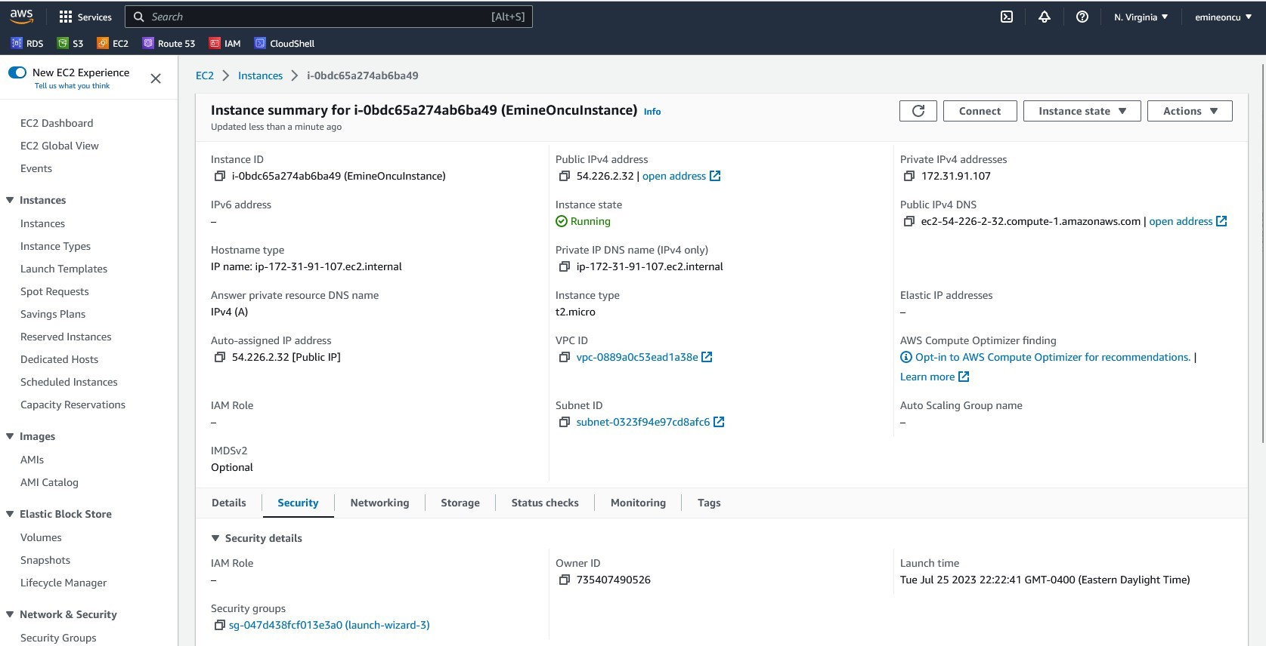

* **We can see Security Groups in the picture below.**

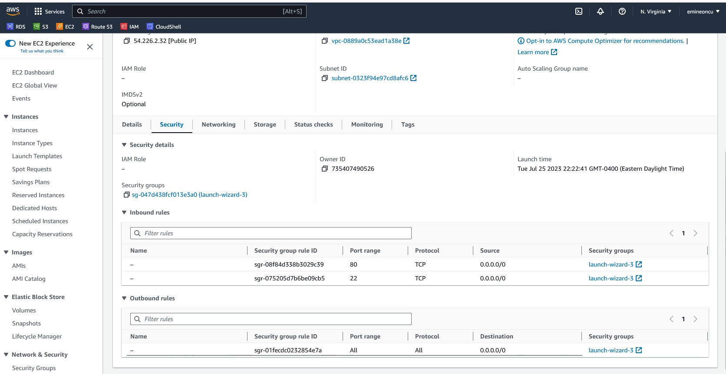

* **Network Interface Section, ENI (Elastic Network Interfaces)**

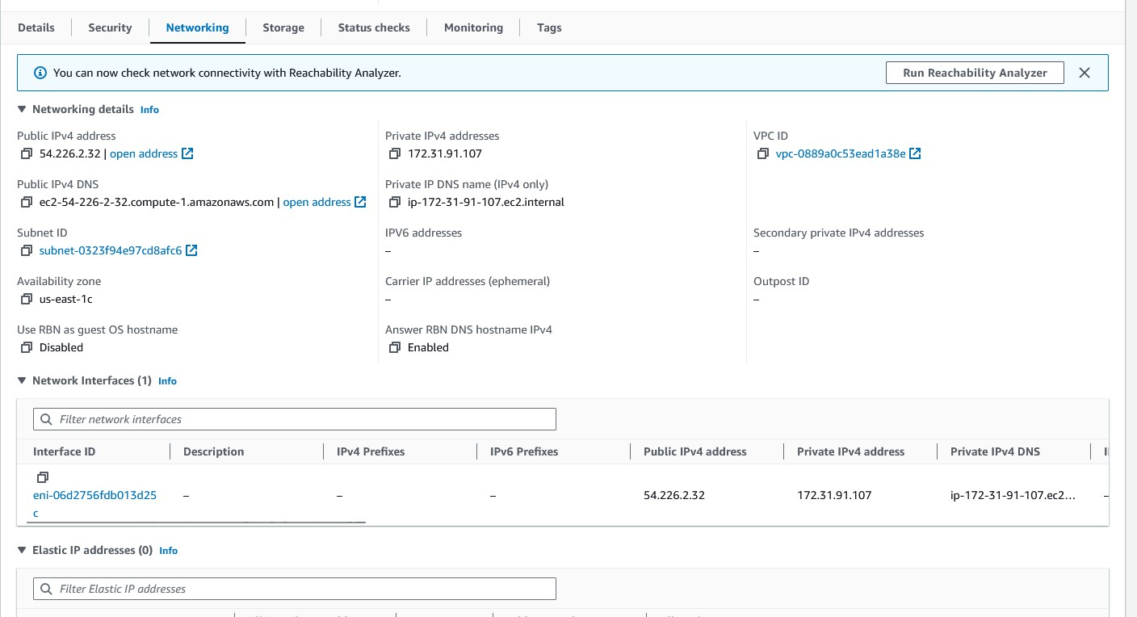

* **EBS volume attached by default.**

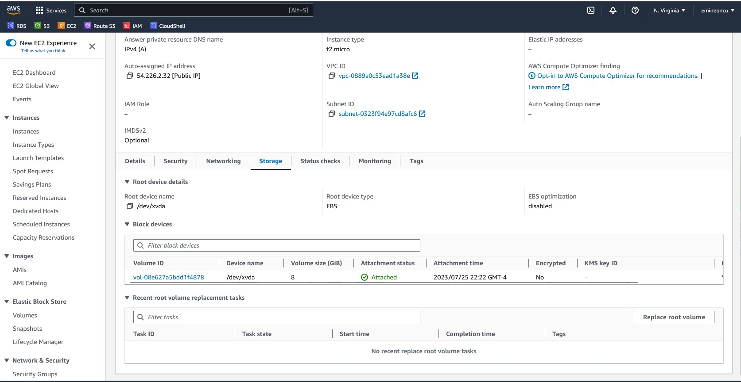

* **Edited user and upload it.**

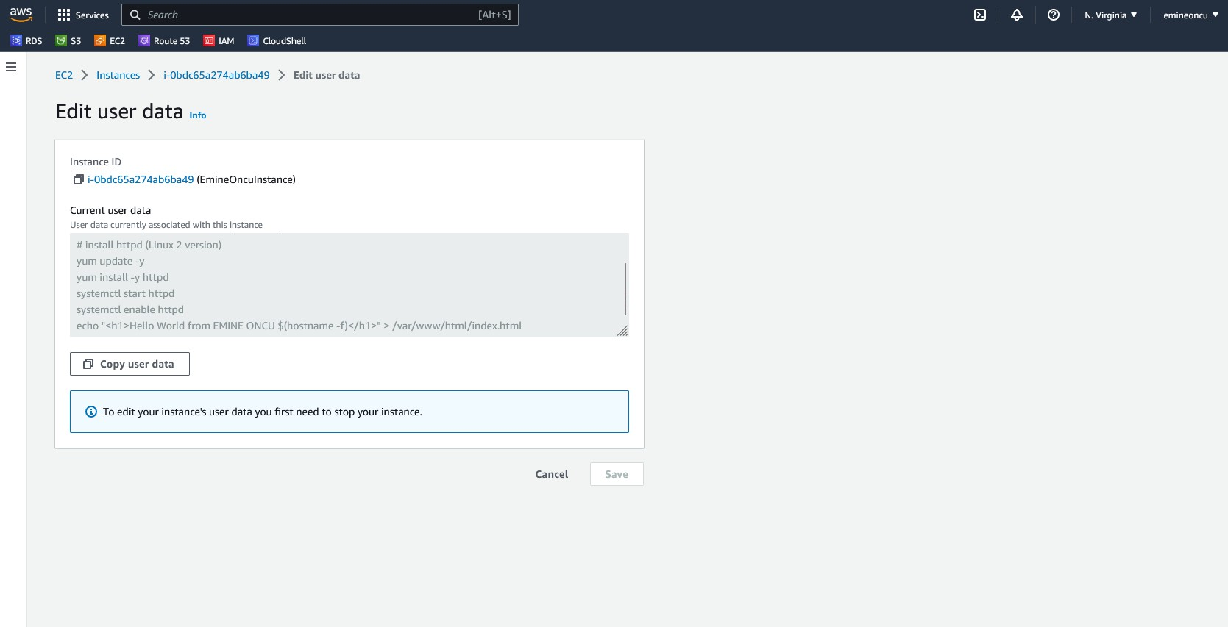

* **Public IPV4 DNS; opened address page in the picture below.**

